

**Hospital Management System for The Mayo Clinic**

**SIMPLILEARN PC BA - CBAP CERTIFICATION PROJECT – 4**

Submitted By:

**Rohan Maity**

Table of Contents

Introduction 3

Business Analysis Core Concept Model (BACCM) 4

Project Tasks 6

1. Identifying Stakeholders 6

1.1 Internal and External Stakeholder Classification 6

1.2 Stakeholder Onion 6

1.3 RACI Matrix 7

2. Workflow of the System 9

3. In-Scope and Out-of-Scope Items of the Software 10

4. Scope of the Hospital Management System 11

5. Main Features to be developed 12

6. ER Diagram of the System 13

7. Data Flow Diagram of the Hospital Management System 14

8. Requirements of the Software 15

8.1 Functional Requirements 15

8.2 Non-Functional Requirements 15

9. Flowchart of Patients’ Admission Process 16

10. Mock Screens for the Hospital Management System 17

# Introduction

The Mayo Clinic is an American non-profit academic medical center currently based in three major locations, Rochester, Minnesota; Jacksonville, Florida; and Scottsdale, Arizona focused on integrated patient care, education, and research. Mayo Clinic holds the number 1 rank among hospitals in the United States.

It was opened on the 30th of September 1889. Over the years it grew in size and facilities. It increased the size of its premises and also the number of doctors it employs. The vast number of patients it treated made the management of such a huge hospital an arduous task. The paperwork and storing of all patients’ records were becoming unmanageable. It was then the management of the hospital decided to invest money in hospital management software. The Hospital Management System is designed to manage all hospital operations.

The 1980s initiated transformative changes that set the course for the modern Mayo Clinic. As an early adopter of the Internet, Mayo Clinic has been recognized for its online communications with patients. The Hospital Management System or HMS is designed to store patients' records, show the availability of beds, manage patients’ billing, schedule a doctor’s appointment, and will bring about coordination among the different departments.



**Figure 1: Mayo Clinic Logo**

# Business Analysis Core Concept Model (BACCM)

The Business Analysis Core Concept Model or BACCM is a business analysis conceptual framework used to evaluate six core concepts of any given business analysis project or task.

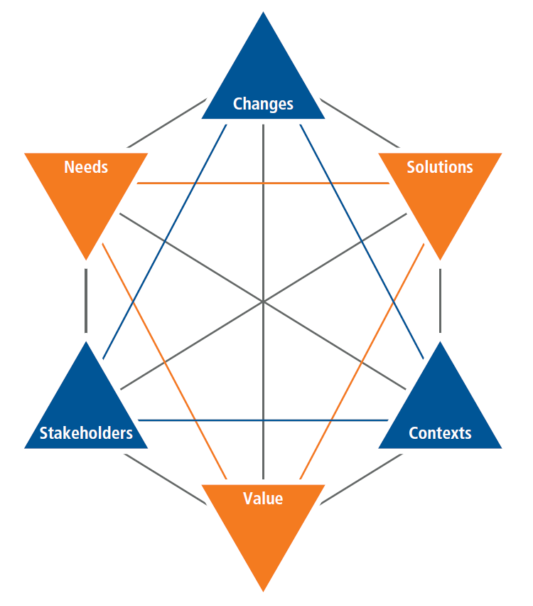

**Figure 2: BACCM Model**

In the context of the HMS of the Mayo Clinic, the application of the BACCM model will yield:

|  |  |
| --- | --- |
| **BACCM** | |
| **Need** | Due to the growing size of the clinic and the increase in the facilities, the management of the increased volume of paperwork as well as storage of patients’ records were becoming very difficult. |
| **Change** | * Switching the paperwork and manual work system for managing patients’ records to a digital software system that can manage all the data efficiently and reduce workload for staff. * The new system will be able to reduce cost of the hospital and workload of the staff while also saving the time of the patients with records management and communication. |
| **Solution** | * Designing, development, and implementation of a Hospital Management System or HMS for effectively and efficiently managing all the hospital operations digitally. * The HMS will be able to store patients’ records, manage their billing, show them availability of hospital beds, schedule doctor’s appointment, and facilitate coordination between the different departments of the hospital. |
| **Context** | * Integrated patient care, education, and research. * Online communication with the patients. * MySQL database to be used for development of the HMS. * HMS will be a web-based application. * HMS will be able to support at least 500 users at any given time. * Ease and user-friendly interface with smooth user experience. * Availability of the system 24/7. |
| **Stakeholder** | * **Internal Stakeholders:** Project Manager, Domain SME, Implementation SME, Tester, and Operational SME. * **External Stakeholders:** Medical Equipment Vendors, Hospital Staff, Senior Management, Patients, and Regulators such as Insurance Companies and State and Federal Laws. * **Business Analyst** |
| **Value** | * Reduced operational costs of the Mayo Clinic hospital. * Reduced workload and time-consumption from staff. * Saving time for the patients. * Safe and secured storage and management of patients’ medical records in cloud storage. * Keeping track of available and filled beds in the hospital. * Reduced documentation process. * Ease of access to the patients’ data. * Effective and efficient online communication with patients. |

**Table 1: BACCM Core Concepts for HMS of Mayo Clinic**

# Project Tasks

## 1. Identifying Stakeholders

### 1.1 Internal and External Stakeholder Classification

The internal and external stakeholders for the HMS of Mayo Clinic are:

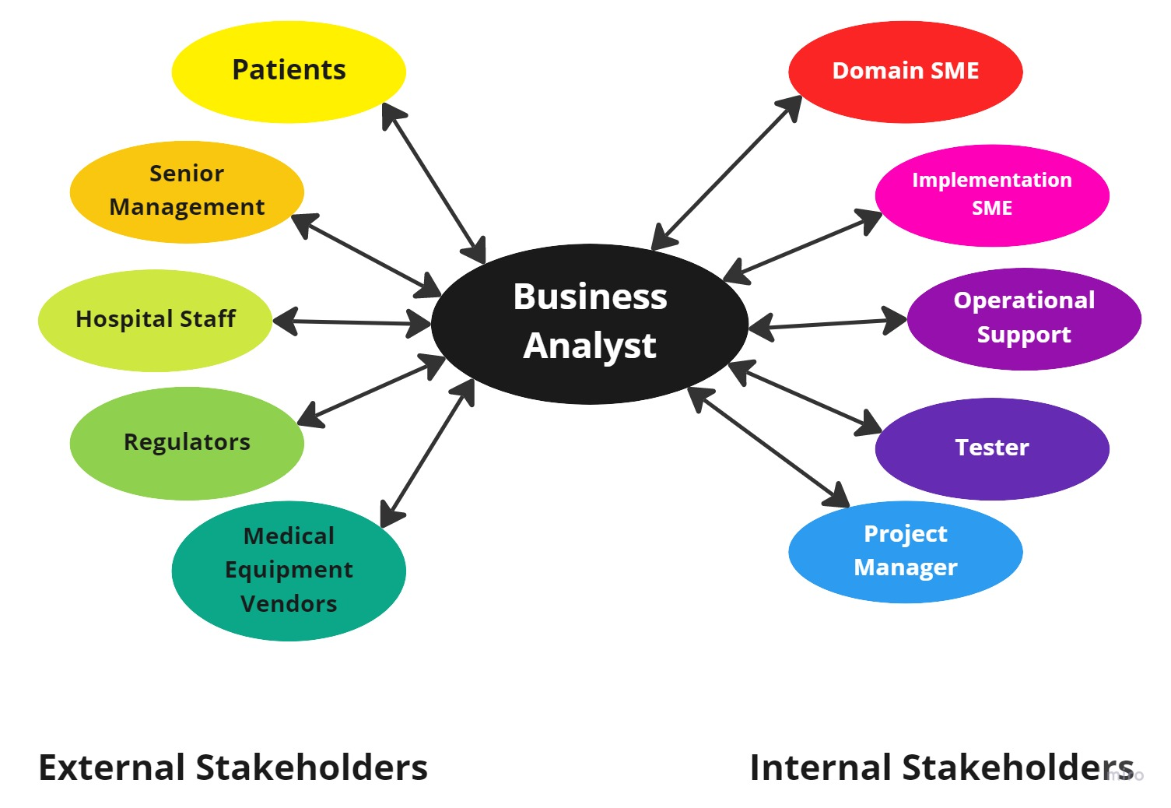

**Figure 3: Stakeholder Classifications**

### 1.2 Stakeholder Onion

The Stakeholder Onion is a diagram that helps to highlight the relationship of the stakeholders with the project goals. In the context of the HMS of Mayo Clinic, the Stakeholder Onion will be:

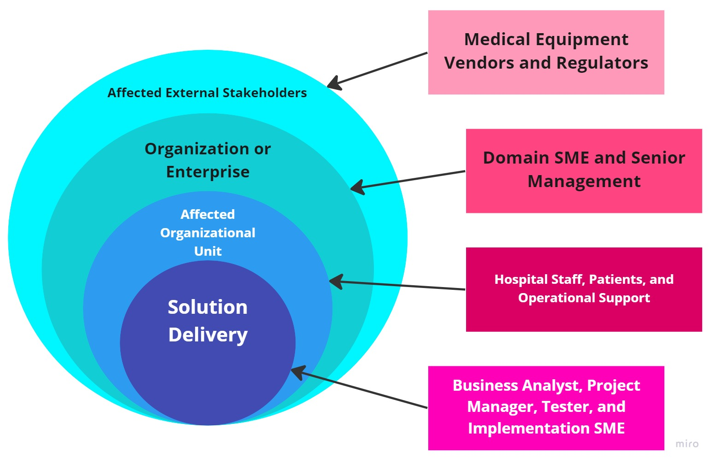

**Figure 4: Stakeholder Onion**

### 1.3 RACI Matrix

The RACI Matrix is a form of stakeholder analysis matrix that categorizes the responsibilities of the stakeholders in a project into 4 different types. These are:

* **Responsible (R):** The stakeholder who will be performing the work on the task.
* **Accountable (A):** The stakeholder who will be held accountable for the successful completion of the task and is the decision-making individual with only one stakeholder being designated this responsibility type.
* **Consulted (C):** The stakeholder who will be asked for or consulted regarding inputs, opinions, information, and advice on the tasks and is generally designated to the subject matter experts (SMEs).
* **Informed (I):** The stakeholder who will be kept updated or notified of the task and its outcomes where information flows in one way and is different from consulted where information flows two-way.

In the context of the project of the HMS of Mayo Clinic, the RACI Matrix will be:

|  |  |  |  |  |
| --- | --- | --- | --- | --- |
| **Stakeholders** | **Responsible** | **Accountable** | **Consulted** | **Informed** |
| **Hospital Staff** | **R** |  |  | **I** |
| **Patients** |  |  |  | **I** |
| **Senior Management** |  |  |  | **I** |
| **Medical Equipment Vendors** |  |  |  | **I** |
| **Regulator** |  |  |  | **I** |
| **Business Analyst** | **R** |  |  |  |
| **Domain SME** |  |  | **C** |  |
| **Implementation SME** | **R** |  | **C** |  |
| **Operational Support** |  |  | **C** |  |
| **Tester** | **R** |  | **C** | **I** |
| **Project Manager** | **R** | **A** | **C** |  |

**Table 3: RACI Matrix**

## 2. Workflow of the System

The workflow of the HMS of Mayo Clinic is:

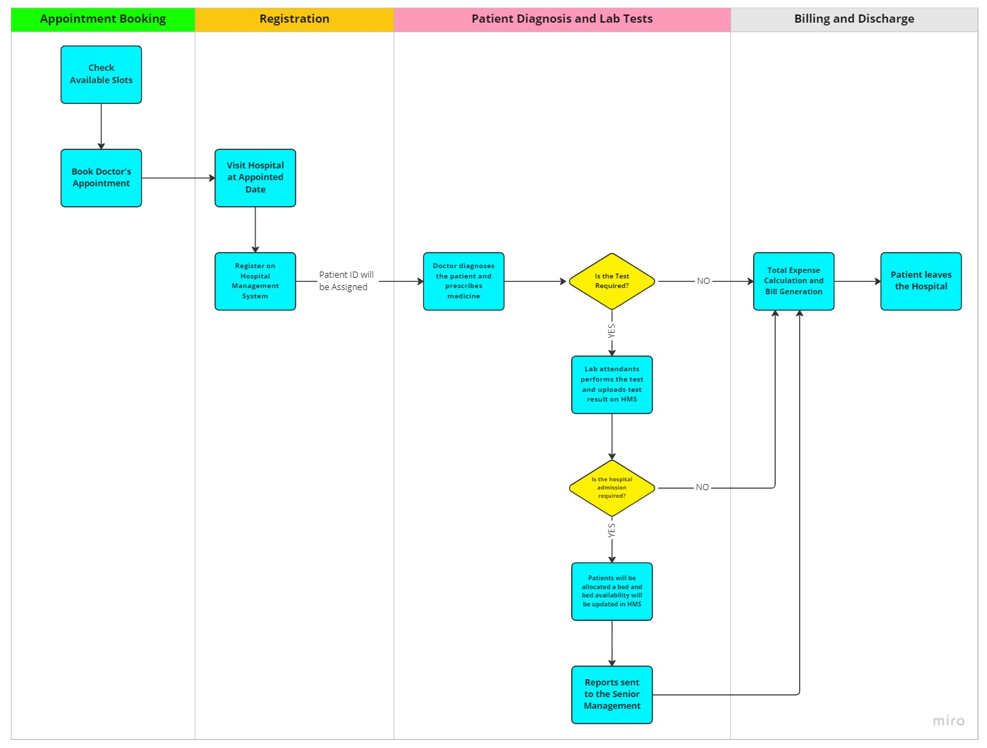

**Figure 5: Workflow of HMS of Mayo Clinic**

## 3. In-Scope and Out-of-Scope Items of the Software

The In-Scope and Out-of-Scope items for the HMS are:

|  |  |
| --- | --- |
| In-Scope | Out-of-Scope |
| 1. Appointment Scheduling | 1. **Emergency department (ICU, Ventilators, Oxygen tanks, Beds etc.)** |
| 1. Appointment reminders | 1. **Hospital payroll management** |
| 1. Patient registration | 1. **Visitor log** |
| 1. Adding/deleting/updating/maintaining patient’s record | 1. **Medical staff’s details** |
| 1. Ordering medical prescription | 1. **Emergency department (ICU, Ventilators, Oxygen tanks, Beds etc.)** |
| 1. Ordering lab tests and lab test results |  |
| 1. Patient admission |  |
| 1. Bed occupancy management |  |
| 1. Staff (nurses and ward boys) management |  |
| 1. Generation of reports |  |
| 1. Billing and Insurance |  |

**Table 4: In-Scope and Out-of-Scope Items**

## 4. Scope of the Hospital Management System

The scope of the HMS of Mayo Clinic can be expressed by the following Context Diagram:

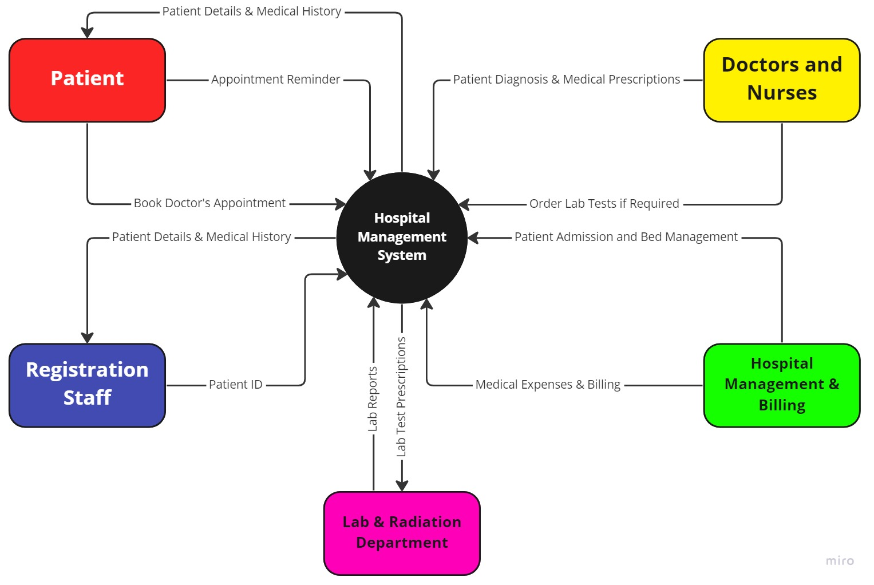

**Figure 6: Context Diagram of HMS of Mayo Clinic**

## 5. Main Features to be developed

The main features to be developed for the HMS of Mayo Clinic are:

1. Capable of effectively managing and safely storing patient records.
2. Capable of scheduling and rescheduling appointments for patients.
3. Capable of setting up patient accounts in the database.
4. Maintaining insurance related processes for the patients.
5. Maintaining and managing the doctors’ profiles in the database.
6. Adding/deleting/updating patients’ records in the database.
7. Allocation of beds and updating availability status of the beds.
8. Generation of reports for the senior management.
9. Allocation of work to the hospital staff members.
10. Billing of medical and treatment costs for patients.
11. Managing prescriptions and test results for the patients.
12. Safe and Secured system with user-friendly interface.

## 6. ER Diagram of the System

The ER Diagram of the HMS of Mayo Clinic can be expressed as:

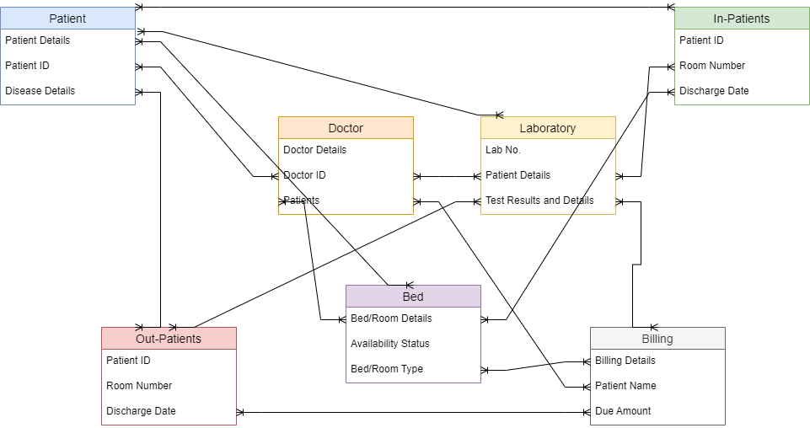

**Figure 7: ER Diagram of HMS of Mayo Clinic**

## 7. Data Flow Diagram of the Hospital Management System

The Data Flow Diagram of the HMS of the Mayo Clinic can be illustrated as:

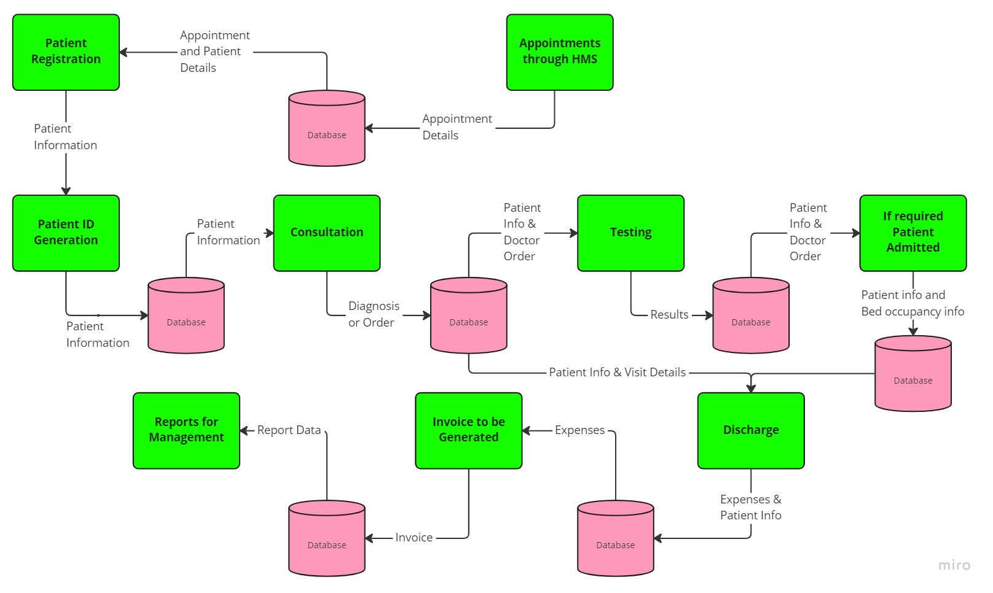

**Figure 8: Data Flow Diagram of HMS of Mayo Clinic**

## 8. Requirements of the Software

### 8.1 Functional Requirements

The functional requirements for the HMS of Mayo Clinic are:

1. Employee login and registration function.
2. Registration functions for the patient.
3. Upload, download, storage and categorization functions for the patient information.
4. Doctor’s Medical Prescription generation function.
5. Patient appointment management function.
6. Laboratory Database.
7. Staff Management.
8. Report Generation.
9. Billing and Insurance.
10. Bed Availability.

### 8.2 Non-Functional Requirements

1. **Availability:** The HMS should be available 24/7.
2. **Compatibility:** The HMS should be able to work easily with all the other functions for each department.
3. **Maintainability:** The HMS is developed by MySQL for the database and thus, it can be updated and maintained easily.
4. **Reliability:** The HMS should be able to log as well as track all the errors.
5. **Scalability:** The HMS should be able to support at least 500 users at any given time.
6. **Localization:** The HMS should be available in English and other optional languages.
7. **Usability:** The HMS should be user-friendly as well as easy to navigate.
8. **Security:** The HMS should be safe and secured as well as compliant with the state and federal regulations.

## 9. Flowchart of Patients’ Admission Process

The flowchart of patients’ admission process in the HMS of Mayo Clinic can be illustrated as:

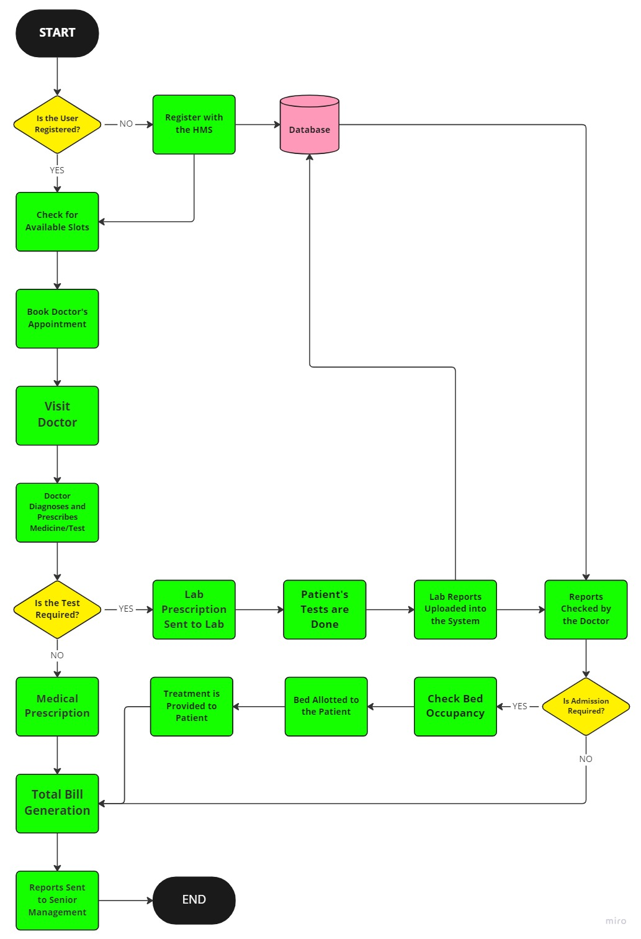

**Figure 9: Patients’ Admission Process in HMS of Mayo Clinic**

## 10. Mock Screens for the Hospital Management System

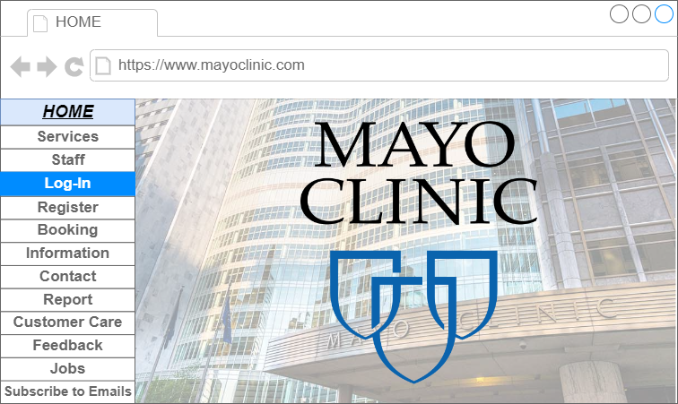

**Figure 10: Mayo Clinic HMS Home Page**

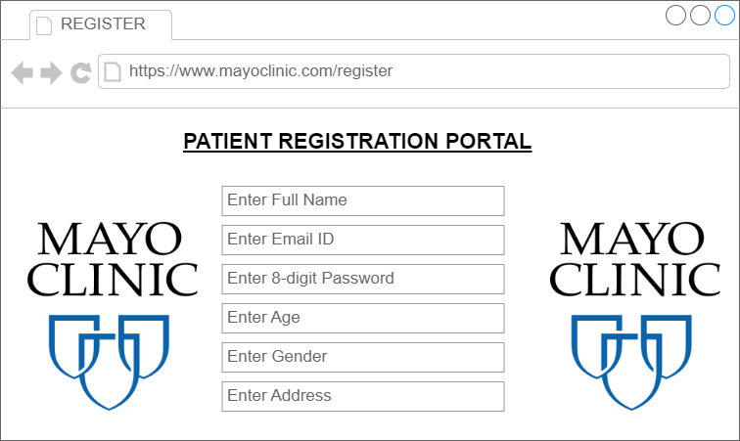

**Figure 11: Mayo Clinic HMS Patient Registration Screen**